Year 7 End of Term Practice Test Name:______________________

Non-Calculator Section

- Complete the following:

  - - 8 + 4 = _____

  - 4 – 6 = _____

  - -7 + 3 = _____

  - - 9 – (-10) = ______

- Use the following symbols to complete the number sentence: < > =

  - 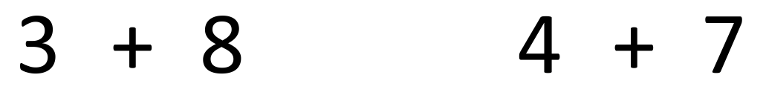

  - 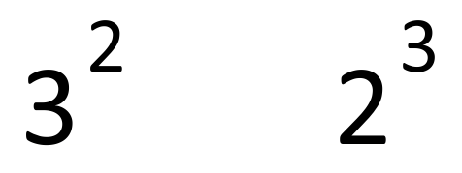

- Write the following in Index Form

  - 5 x 5 x 5 x 5 = __________

  - 3 x 3 x 3 = _________

- Write the following in Expanded Form

  - 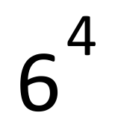 = _____________________________

  - 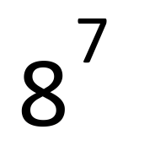 = __________________________________

- Evaluate the following:
64
  - 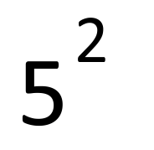 = ________

  - 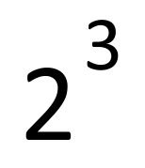 = ________

- Use a factor tree to find the prime factors of 64.

  - Prime Factors of 64 = _____________________ (Hint: index notation)
- Evaluate the following square and cube root numbers:

  - 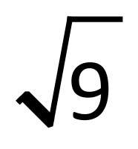 = _______

  - 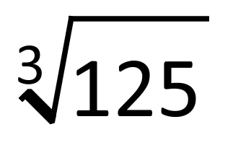 = ________

Calculator Section

- Find the perimeter of the following:
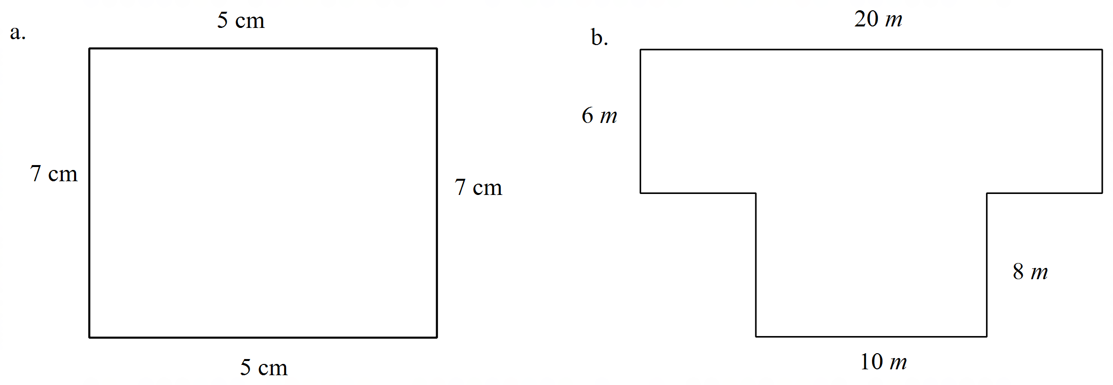

P = P =

- Find the area of the following:
